# Exercise: CSS & Typography

Problems for exercises and homework for the ["HTML and CSS" course @ SoftUni](https://softuni.bg/trainings/2983/html-and-css-may-2020). Submit your solutions in the SoftUni Judge system at <https://judge.softuni.bg/Contests/#!/List/ByCategory/134/HTML-and-CSS-Exercises>.

## My First CSS Document

Create a web page like the following:

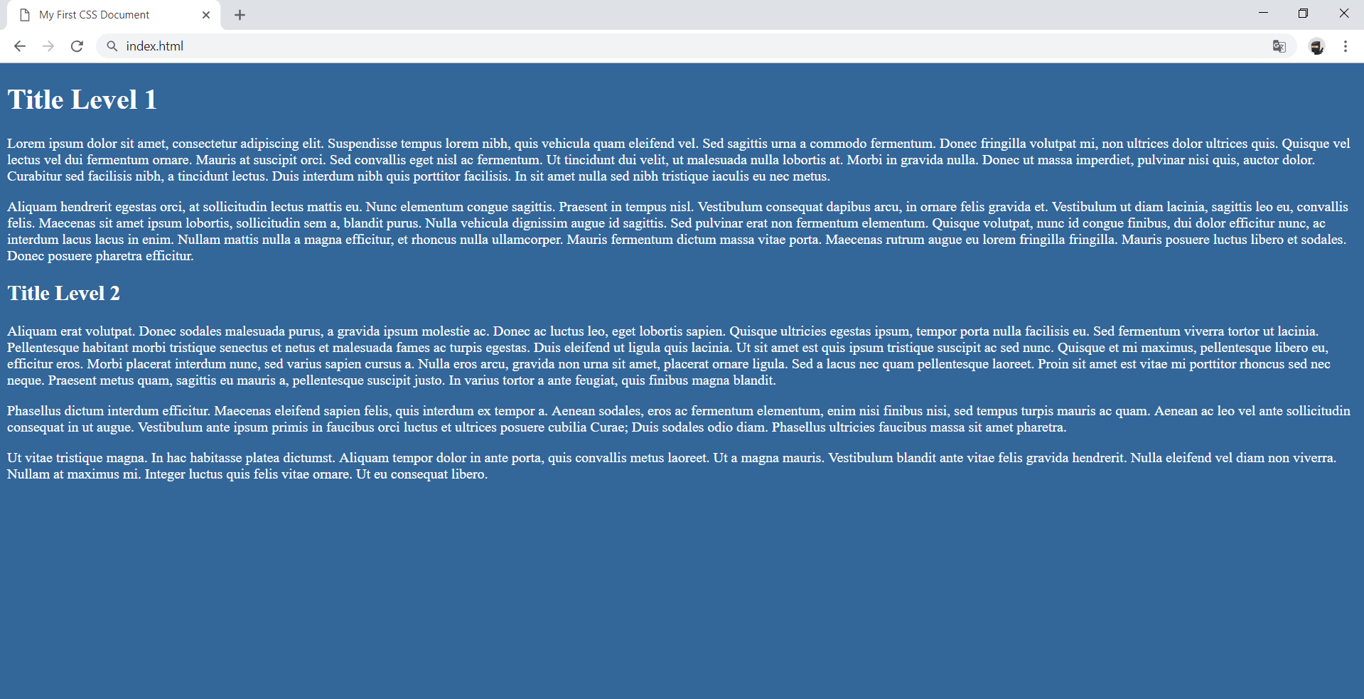

### Constraints

* Change the document **title** to "**My First CSS Document"**
* Use h1 and h2 tags for headings
* Use background with color - rgb(51, 102, 153)
* Use white **color** for text

## Style Lists

Create a web page like the following:

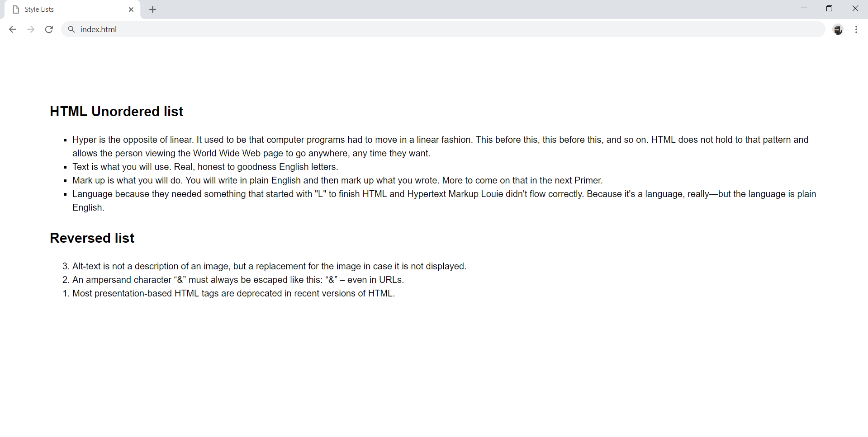

### Constraints

* Change the document **title** to "**Style Lists"**
  + Use font-family: Helvetica, sans-serif, with font-size: 16px and line-height: 1.5
* Add section with two articles inside (for each list)
* Each article must have a h2 heading
* Use ul for unordered list
  + Add **4** list items
* Use olreversed for ordered reversed list
  + Add **3** **list** items

## Styling Tables

Create a web page like the following:

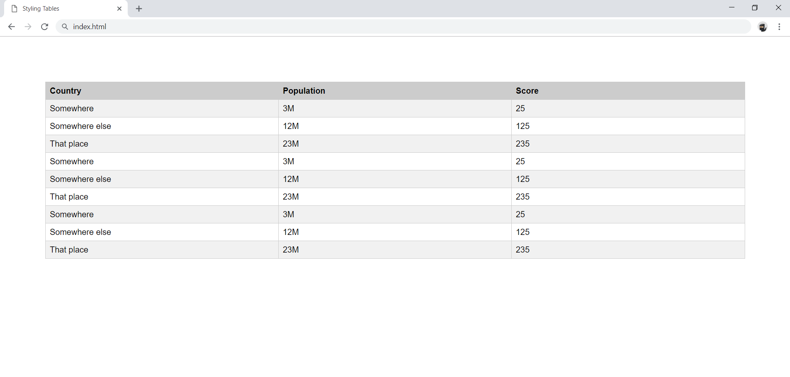

### Constraints

* Change the document **title** to "**Styling Tables"**
* Use tabletag
  + Use thead and tbody tags
  + Style the odd tr tags with background: rgb(241, 241, 241)
  + Style the td tags in every odd row with background: rgb(241, 241, 241)
  + The table, td and th tags must have
    - Border width - 1px
    - Border color - rgb(221, 221, 221)
    - Border style - solid
* When you **hover** the table row, the following styles must be updated:
  + Background: rgb(0, 0, 0)
  + Text color: rgb(255, 255, 255)

## Buttons CSS

Create a web page like the following:

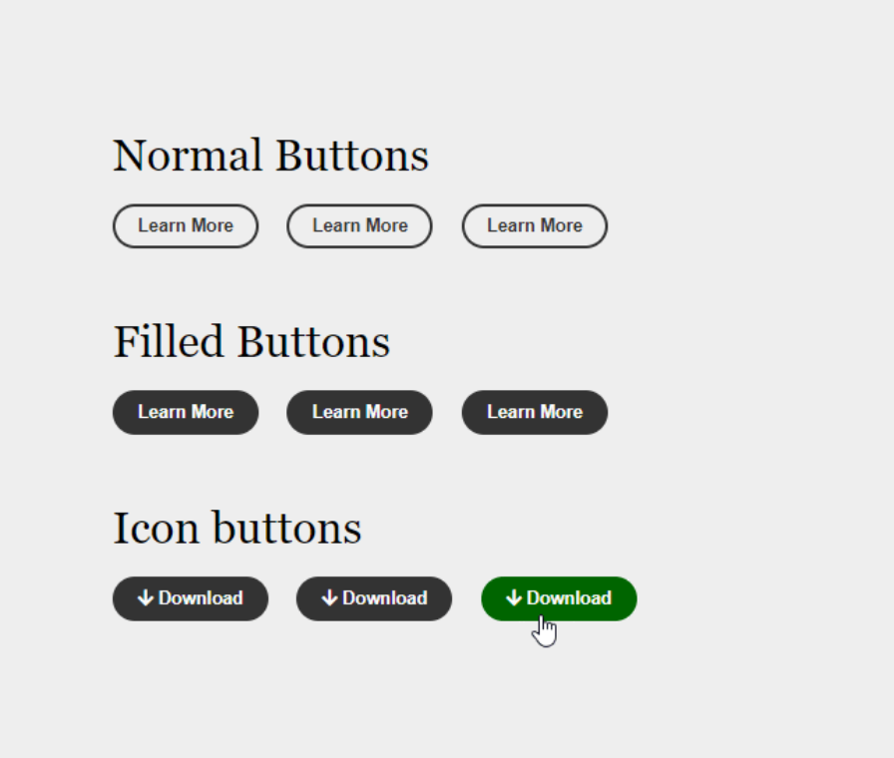

### Constraints

* Create an **"**index.html**"** file with title - **"**Buttons CSS**"**
* Use h2 tag for headings
* Create 9 buttons on 3 rows with class button
  + For the first button in each row use a tag
  + For the next two buttons in the row use button tags
  + The buttons in the second and the third row should have class - fill
  + Every last button in the row should have class - hover
* You must use the following three colors:
  + green(rgb(0, 102, 0))
  + white(rgb(251, 251, 251))
  + gray(rgb(51, 51, 51))
* Use **FontAwesome** for this task. Import it in your CSS, with the **@import** rule.

### Hints

* Change the **cursor** property to [pointer](https://www.w3schools.com/cssref/pr_class_cursor.asp)
* Change the **outline** property to [none](https://www.w3schools.com/Css/css_outline.asp)

## Fonts Speciment - Cormorant + Lato

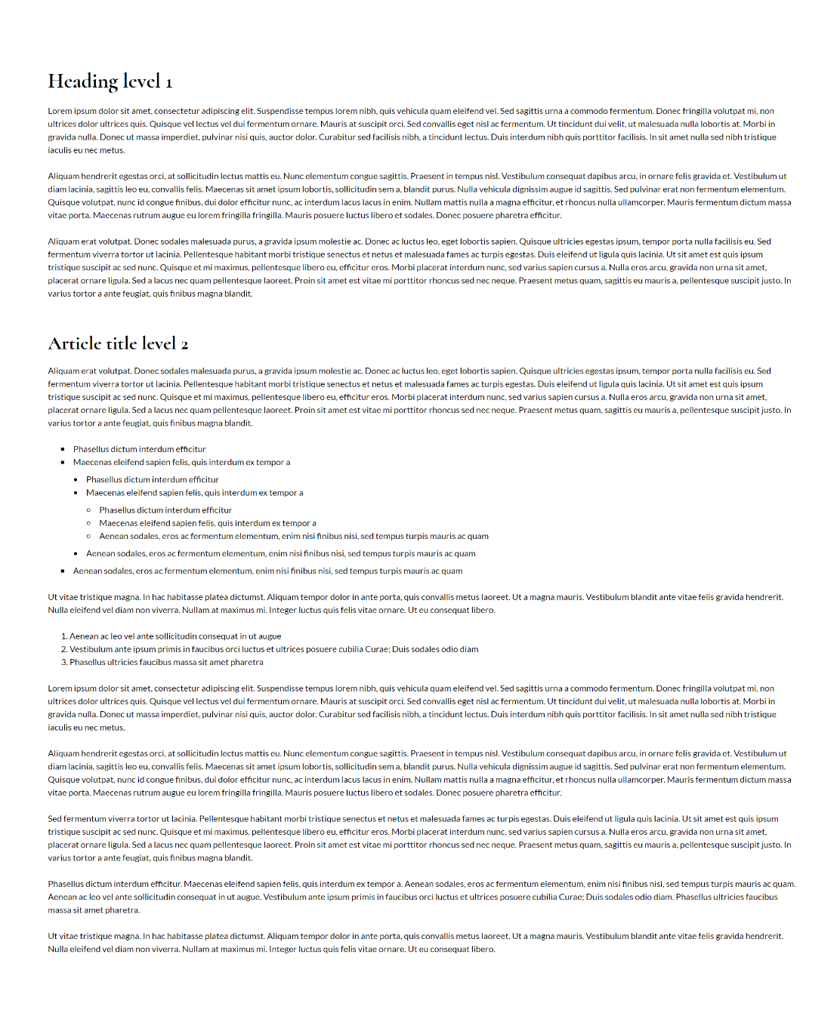

### Constraints

* Create an index.html file with Fonts Speciment Cormorant + Lato title
* Use Lato, sans-serif font-family for the document
  + Make the font-size 16px
  + Change the line-height to 1.5
* Use Cormorant, serif font-family for the headings
  + Change the line-height to 1.2
  + Change the font weight to **bold**

## Fonts Speciment - Great Vibes + Raleway

Create a web page like the following:

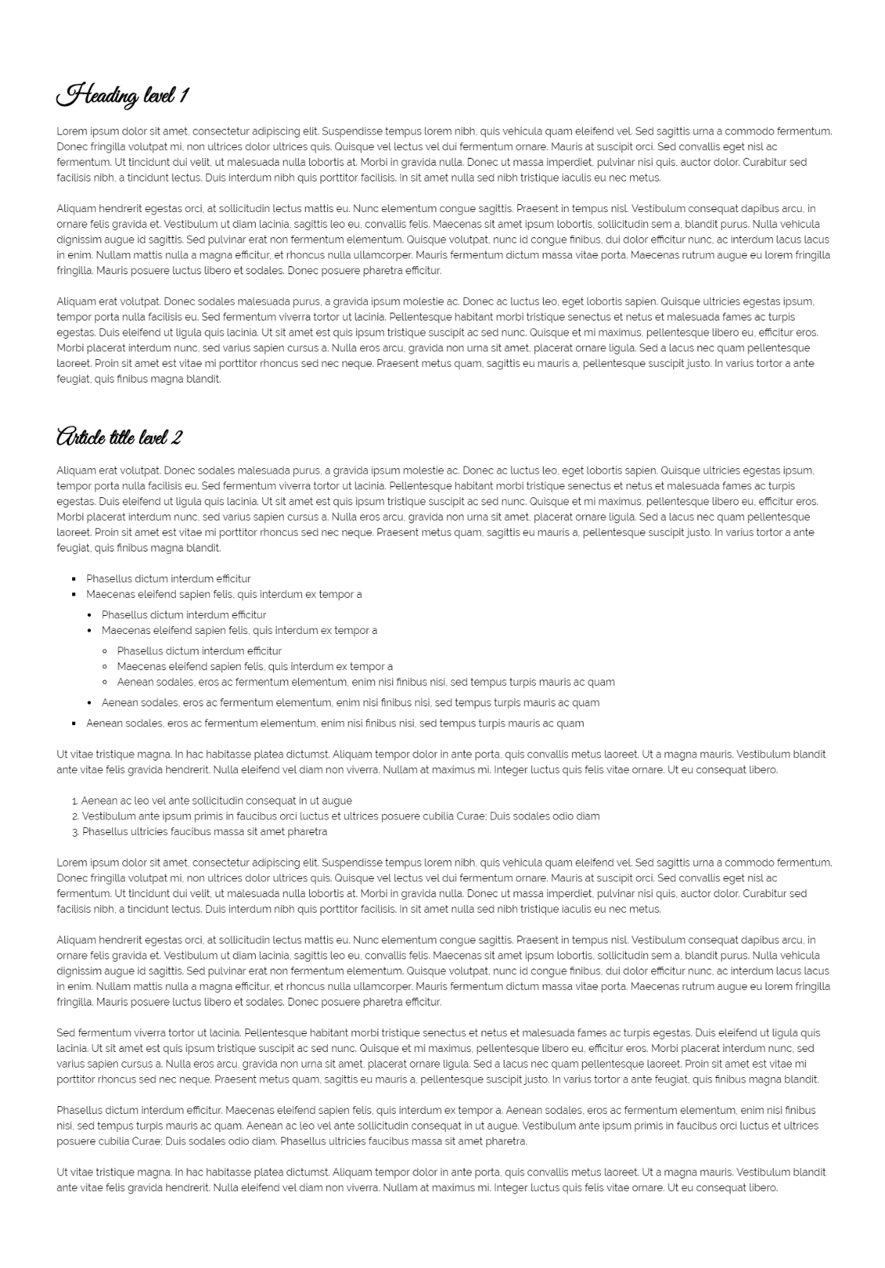

### Constraints

* Create an index.html file with "**Fonts Speciment Great Vibes + Raleway**" title
* Use Raleway, sans-serif font-family for the document
  + Make the font-size 16px
  + Change the line-height to 1.5
* Use Great Vibes, cursive font-family for the headings
  + Change the line-height to 1.2
  + Change the font weight to **bold**

## Contrasting Colors

Create a web page like the following:

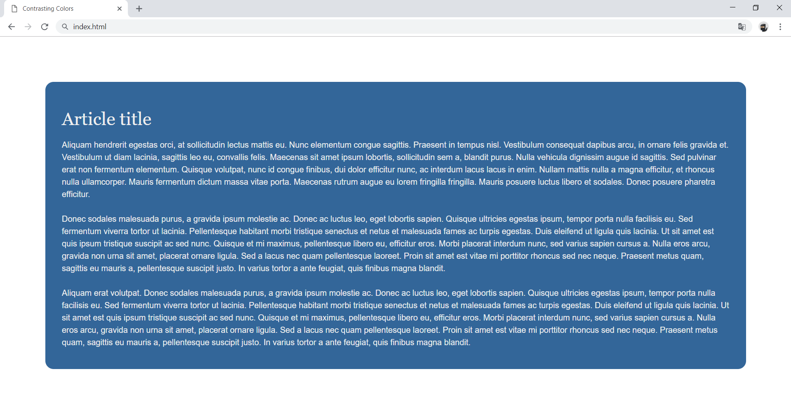

### Constraints

* The document title should be "**Contrasting Colors"**
* Create an article inside the body
  + Make the background with rgb(51, 102, 153) color
  + Set the border radius to 1rem
* Use Helvetica, sans-serif font-family for the document
  + Make the font-size 16px
  + Change the line-height to 1.5
* Use Georgia, serif font-family for the headings

## Icon Font Buttons

Create a web page like the following:

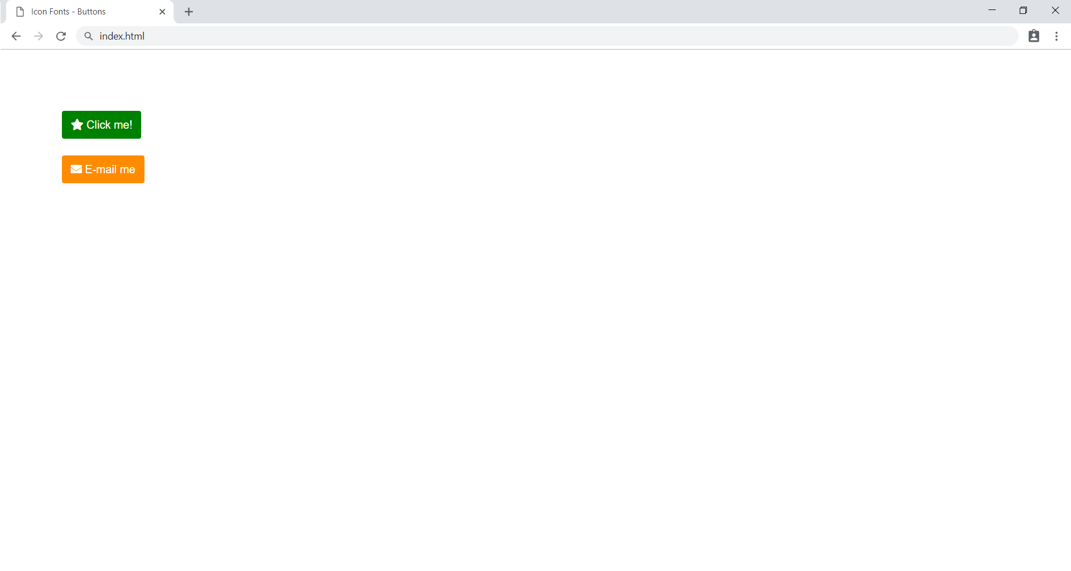

### Constraints

* The document title should be "**Icon Fonts - Buttons**"
* Each of the **paragraphs** should have exactly 1 **anchor** (*<*a*>*)
* Each of the **anchors** should have exactly one **icon element** (<i>)
* The **first anchor** should have text - "Click me!"
* The **second anchor** should have text - "E-mail me"
* The **page** should be styled, exactly like the provided screenshot
* Use **FontAwesome** for this task. Import it in your CSS, with the @import rule

## Icon Font List

Create a webpage like the following:

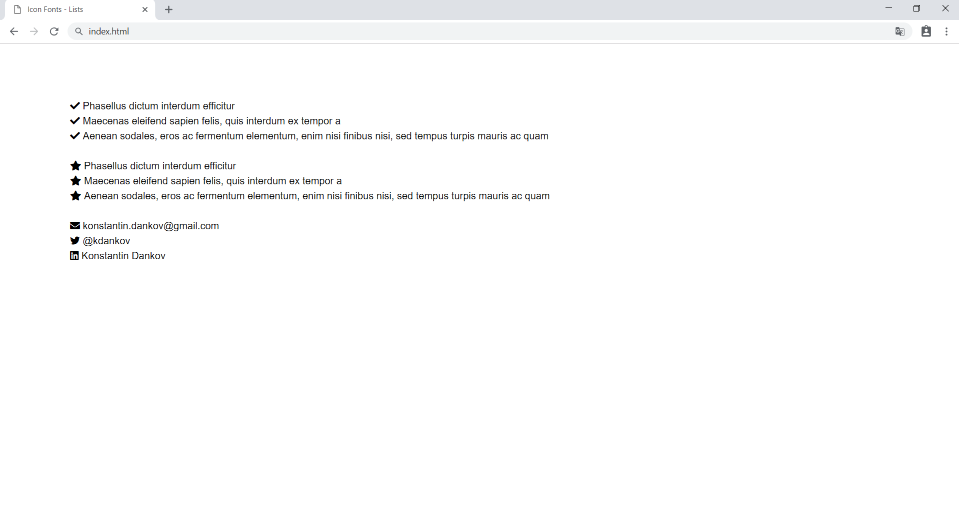

### Constraints

* The **title** of the document should be "**Icon Fonts - Lists**"
* The **unordered lists** should have class - "icons"
* Each of the **unordered lists** should have exactly 3 **list items** (li)
* Each of the **list items** should have exactly one **icon element** (i)
* The **page** should be styled, exactly like the provided screenshot
* Use FontAwesome for this task. Import it in your CSS, with the @import rule

## Create Typography CSS

Create a web page like the following:

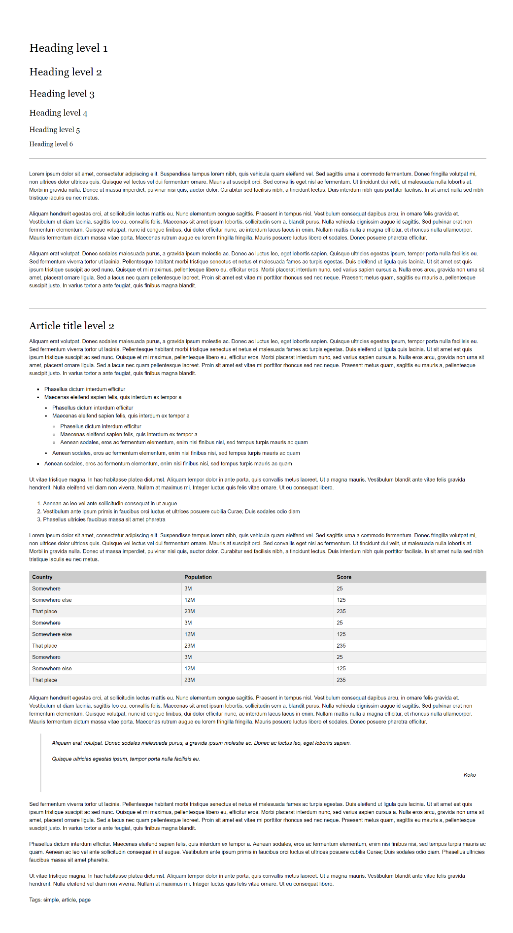

### Constraints

* Create an **"**index.html**"** and **"**style.css**"** files
* Change the document **title** to "**Typography**"
* Use Helvetica, sans-serif font-family for the document
  + Make the font-size 16px
  + Change the line-height to 1.5
* Use Georgia, serif font-family for the headings
* Use headings from h1 to h6
* Create a HTML table and style it
* Use blockquote tag
  + Style its left border with rgb(221,221,221) color
  + Style its font to italic
* Use hr tag for the horizontal lines

## Font Speciment PT Sans

Create a web page like the following:

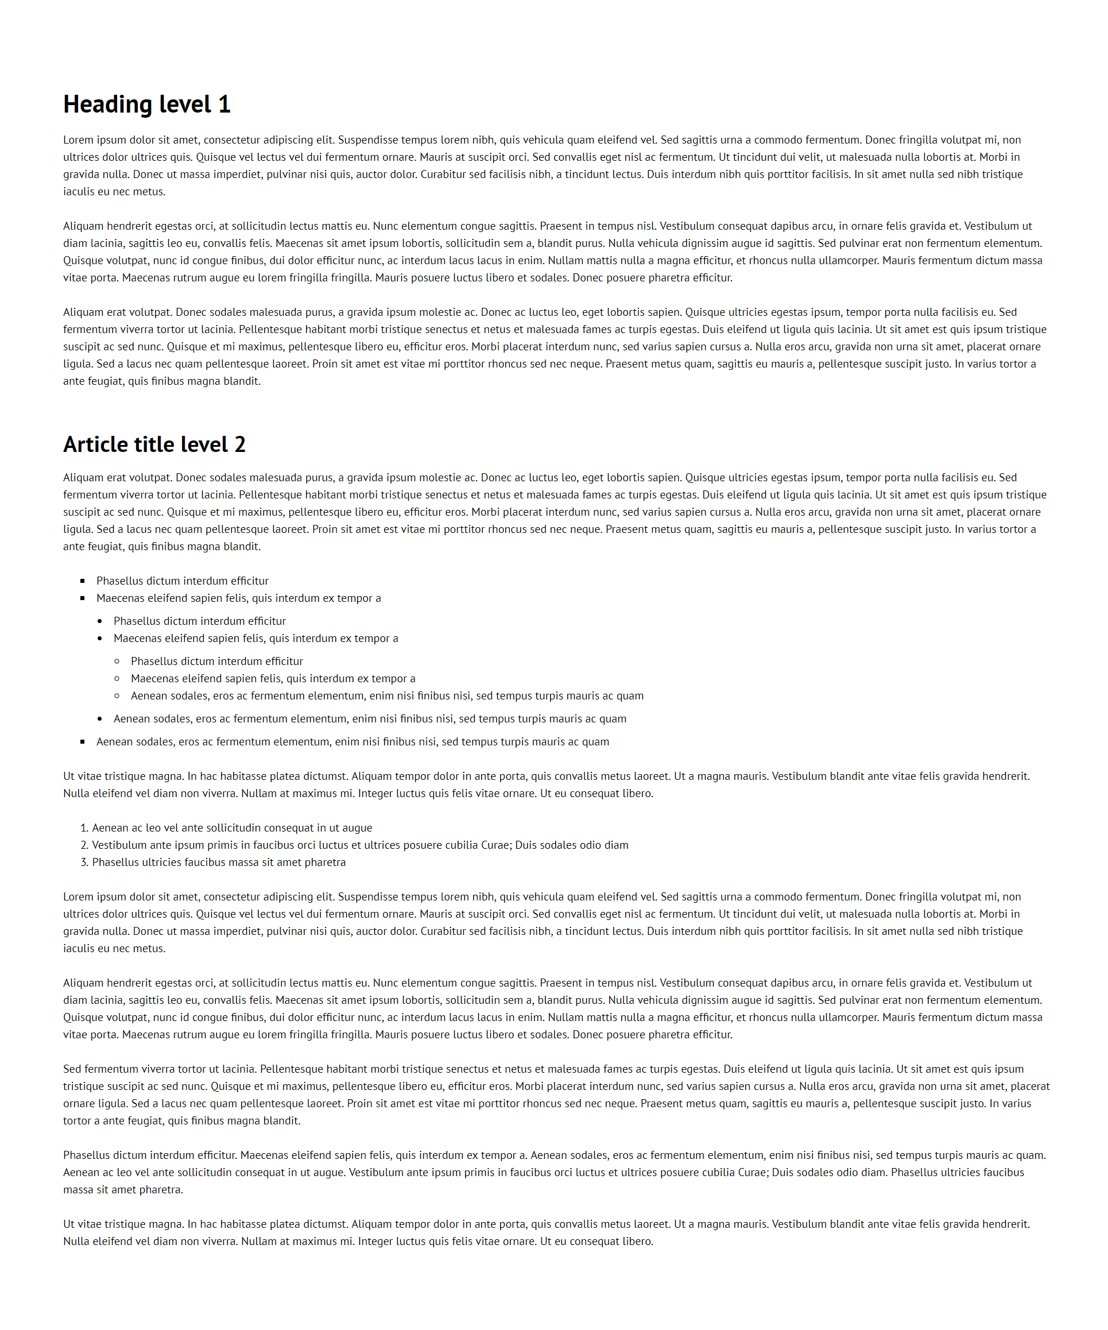

### Constraints

* Create an index.html file with Fonts Speciment PT Sans title
* Create an HTML page which holds an article
* Use h1 and h2 tags for headings
* Use ul and ol tags for lists
* Use PT Sans font-family for the document
* Make the font-size 16px
* Change the line-height to 1.5